Brandon Hough

CPEN 3710

LQF316

Lab Exercise #10

**Console Output (Winning Possibilities):**

case 1: 0 white & 1 yellow with $2 winnings.

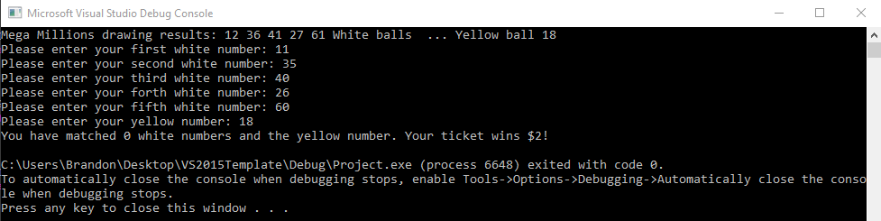

case 2: 1 white & 1 yellow with $4 winnings.

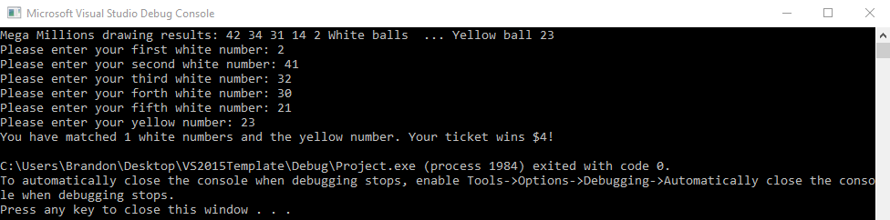

case 3: 2 white & 1 yellow with $10 winnings.

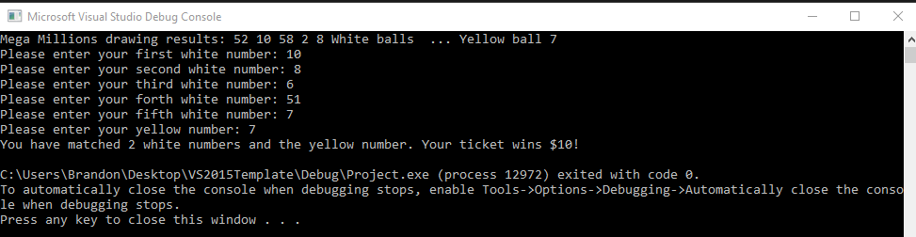

case 4: 3 white & 1 yellow with $200 winnings.

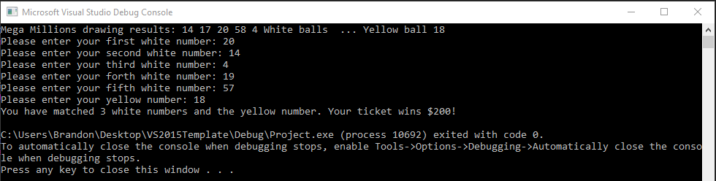

case 5: 4 white & 1 yellow with $10,000 winnings.

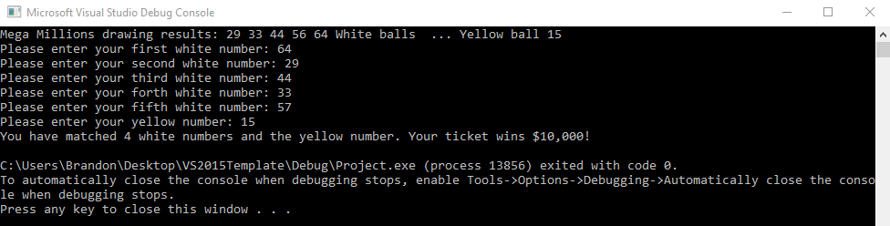

case 6: 5 white & 1 yellow with Jackpot winnings.

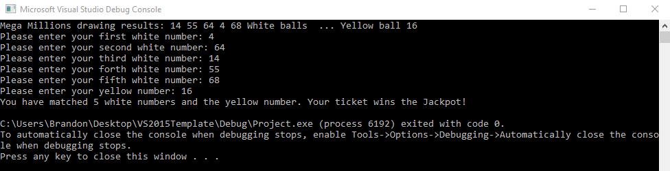

case 7: 3 white & 0 yellow with $10 winnings.

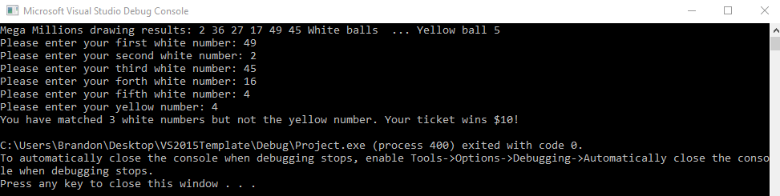

case 8: 4 white & 0 yellow with $500 winnings.

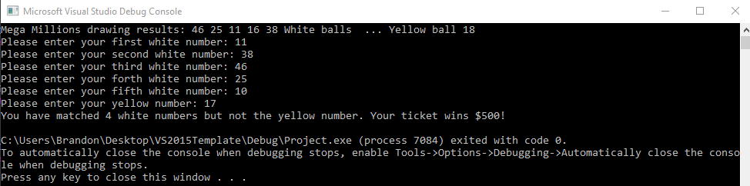

case 9: 5 white & 0 yellow with $1,000,000 winnings.

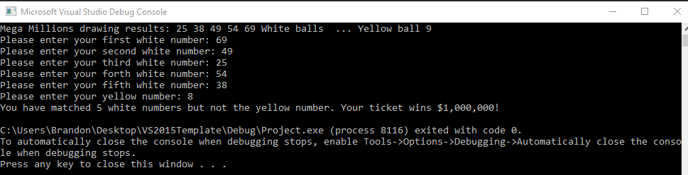

**Console Output (Losing Possibilities):**

case 10: 0 white & 0 yellow with $0 winnings.

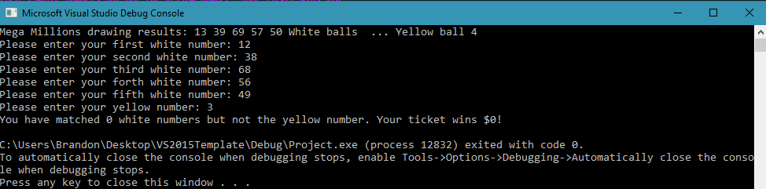

case 11: 1 white & 0 yellow with $0 winnings.

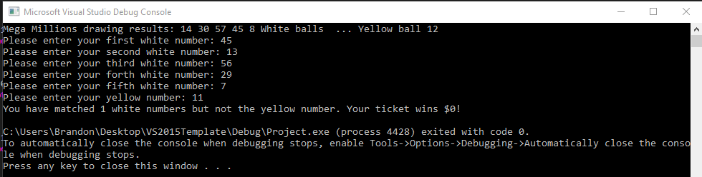

case 12: 2 white & 0 yellow with $0 winnings.

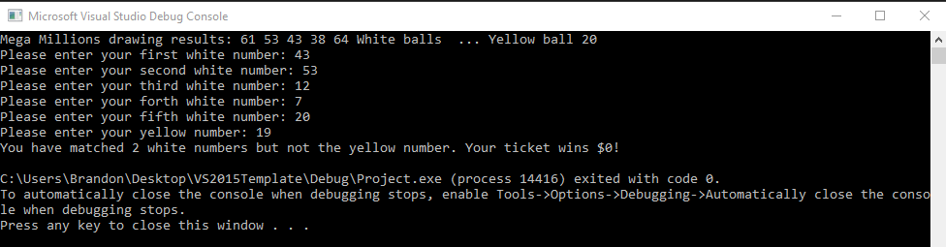

**Console Output (invalid input):**

